Microcontroller Programming with the Arduino

Intro

Audience
This tutorial pdf is intended for those students currently studying the first year programming course in C. It will teach you the basics of programming the arduino microcontroller without any assumptions that the reader knows anything about electronics, all basic concepts are learnt along the way.

Your kit
As part of your course you should have access to the arduino and the ICs (integrated circuits allow you to extend the functionality of your arduino), ask your teacher about these if you haven’t got a hold of them yet (you may have to pay a small fee for the kit).
It should look like the following:
Here is a small decription of each element (don’t worry if you don’t have a particular item, it may have been taken out for repairs or been removed from the course).
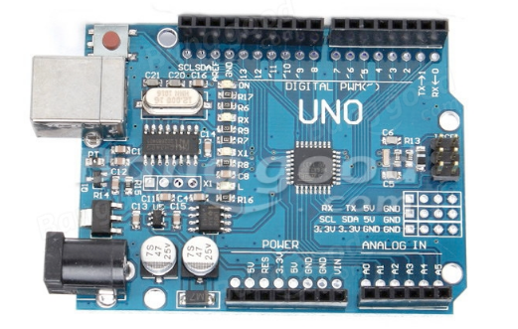
The Arduino microcontroller.

